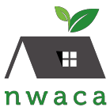
2022 BUSINESS MEMBERSHIP FORM

Level of Membership:

Platinum ($1,000+) Gold ($500-$999) Silver ($250-$499)

Name of Business Member:
Business name to list:
Mailing Address:
Phone Number: | Contact Name:
Website Address: | Contact Email Address:
NOTE: The deadline for memberships to be acknowledged in our July 4th flyer and be included on the T-Shirt is May 15, 2022.
If you have any questions, please feel free to contact our NWACA Business Membership Chair: Julie Waidelich at: julieswaidelich@gmail.com.

Payment made be made online at: https://nwaca.org/how-to-be-a-business-member/ OR By mail: NWACA, P.O. Box 26654; Austin, TX 78755.

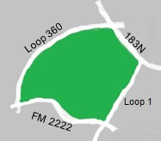
13,580 households.
Founded in 1970.
Learn more at www.nwaca.org

