NWACA Questions: Information from CM Alter’s Office – September 23, 2020

Highlights:
- Council reinvested millions of dollars into community resources that improve public health and safety and can help prevent some of the issues we are seeing in our community. Immediate community investments include:
  - workforce development
  - mental health services
  - homelessness services
  - increased EMS staff and resources
  - substance use services
  - the establishment of the Office of Violence Prevention
  - food access
  - re-entry programs for the formerly incarcerated
  - new Victim Services staff and resources, and more.
    - You can read more about the budget in Council Member Alter’s budget newsletter.

- From 2010-2020 Austin Police Department budget grew over 83%, and in that same time frame, the City of Austin population grew only 26.9%. As we can see, the police department budget has outpaced the population growth by over twice the amount, and our outcomes have stayed relatively the same across that time frame.
  - Population data from the City Demographer: https://www.austintexas.gov/department/demographics
  - APD Budget Data: FY10 Budget Document (APD Budget = $240,737,419)
  - APD Budget Data: FY20 Budget Tool (APD Budget = $440,994,033)
- For the 2020-2021 budget, no officers were fired, no pay was cut, no functions were eliminated. In fact, APD sworn personnel will receive a 2% pay raise across the board, per the 2018 Meet and Confer contract obligations.
- In the 2020-2021 budget, the Council did not cut the police department by $150 million. Only about $20 million was cut from the department effective on Oct. 1, 2020 (about 5%). The remainder of the “$150 million” are departmental units that will be explored for civilianizing and/or separating out from under APD to make the functions independent, or they are units that have been identified for further community conversation about whether and how to reassign those functions to civilian staff or restructure the functions to meet today’s needs.
- Cadet classes were postponed per a Dec. 2019 Council resolution following years of issues and problems with the department (detailed below).
- Analyses have found that officers are spending much of their time on non-emergency, non-violent calls, indicating a large opportunity for improvement in time efficiency and effectiveness of service (more info below).

Why were the cadet classes postponed?
- In a resolution in December of 2019 the city council ordered a revamping of the cadet classes and called for comprehensive audits of APD. The February 2020 class was still allowed to take place, and the expectation at the time was that APD would complete the audits and implement the improvements by June 2020 so as to not disrupt the flow of cadet classes. The December discussion was very clear that no further classes would take place without serious revisions to the curriculum. The audits initiated in the December resolution came after years of known issues with APD operations and culture. Previously, these issues had only been addressed piecemeal at best, and these audits dive deeper into structural and systemic issues.
- A few examples of problems with APD include:
  - The Science of Policing Equity Measuring Fairness in the Austin Police Department: This brief analyzes “APD traffic stops and searches, as well as APD officers’ use of force, for the calendar years 2014 and 2015. For both yearly analyses we isolate race and ethnicity, exploring differences in practices and modeling these outcomes of interest while controlling for competing factors, such as place-specific crime rates. The raw data point to disparate treatment of Austin citizens based on race and ethnicity in vehicle stops and in use of force. For use-of-force incidents, black and Hispanic communities remain more likely to experience use of force than white communities after adjusting for community-level differences in crime and poverty. These findings demonstrate that even in an agency such as the APD, which is instituting reforms aimed at enhancing equity in policing, unwelcome disparities remain, indicating that more work is needed within and beyond law enforcement agencies.”
  - The class action lawsuit filed by sexual assault survivors against APD, COA, Chief Manley, Chief Acevedo, and more: read it in its entirety here.
    - A second lawsuit was filed by additional survivors on Sept. 15, 2020. You can read that lawsuit here.
  - Office of Police Oversight and Equity Office’s Joint APD Racial Profiling Report: One finding from the executive summary revealed racial disparities in motor vehicle stops in 2018, with Black/African Americans as the most overrepresented of all racial/ethnic groups in Austin.
  - Austin crime lab bucked DNA standard for years, yet got passing grades – Statesman article showing years of problems with APD’s crime lab that were ignored by supervisors
  - 2018 Letter to the City from Former Cadets About Issues with Academy Culture of Violence – Read the Statesman article here

- In December 2019, the Council passed a resolution (read it in its entirety here) by Council Member Harper-Madison that contracts with multiple independent experts to conduct in-depth audits into various aspects of the police department:
  - “the extent to which forms of bigotry and discrimination are present in the protocols, practices, and behaviors of the officers of the Austin Police Department, and multiple allegations of racism and homophobia”
  - “an audit of the Austin Police Department's training materials, course/section descriptions and duration, and description of any other procedures (e.g. detailed descriptions of scenarios) administered to cadet classes and to active officers related to training on communication strategies, cultural competency, acknowledging and addressing bias, use of force, de-escalation, search, proactive policing, mental health response, protocols for non-English speaking persons, protocols for disabled persons, recognizing resistance and the rules and procedures that define resistance and their evaluation protocols, as well as the course/section content and duration of all other coursework required at the cadet academy and their evaluation protocols”

- The department was supposed to have completed this review by June 2020. Council voted to move forward with the Feb. 2020 class with the anticipation that the academy review would be completed by June 2020. The department has asked for time extensions, and staff currently expects the review to be completed by the end of the 2020 calendar year.

What aspects of APD are being moved out of the Police Department and why?
- In the spreadsheet below, you can see a breakdown of the framework for potential change to the Austin Police Department. It is important to note that the only decided-upon funding cuts to the Austin Police Department are what is shown in the first funding category labeled “Immediate Reinvestment”. The second category labeled “Decouple Fund” includes civilian operations and some sworn functions that City staff will work to make independent from the Austin Police Department to better integrate those units across all City functions. The third category labeled “Reimagine Safety Fund” identifies functions to be discussed for restructuring, right-sizing, and reassigning to other professionals as part of the long-term “Reimagining Public Safety Process”. Learn more about that process at http://austintexas.gov/publicsafety. Note the Contractual Obligations for EMS represent new investments, but that $1,269,806 does not come from the APD budget which is why we talk about approximately a $20 million cut.

Below is the spreadsheet for the first funding category:
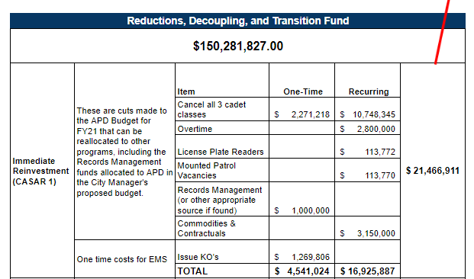

- Immediate Reinvestment: The Austin Police Department was cut by about $20 million dollars, equating to about 5% of its total budget of $434 million. About half of those funds come from the postponed cadet classes, which are detailed above. Overtime cuts adjust for anticipated reductions in officer time as a result of reduced large events and gatherings due to COVID-19. Overtime reductions also reflect future changes to officer time per the reassignment of non-violent/non-emergency calls for service outside of police and the restructuring of certain functions to become civilian-run operations, which will allow officers in the restructured functions to be reassigned to patrol/policing functions (for example, civilianizing “Support Services” would release the sworn personnel in that unit to patrol or other policing functions). Once the necessary cadet academy reviews are completed and the revisions are implemented, the Council has the ability to pass a budget amendment to reinstate the academy, as laid out in the joint budget amendment by Mayor Adler, CM Alter, CM Tovo, and CM Harper-Madison, which was accepted as budget direction:
  - “Cadet Class. We agree that one of the anticipated benefits of reimagining public safety is a decreased need for the number of sworn officers. We also need to acknowledge that cadet classes present a real opportunity to reform police training, create and spread change agents and to improve racial diversity and culture at APD. We are supportive of using the full funding from cutting all three classes to invest in other areas of public safety, but we also believe we should not rule out the possibility that one or two of those classes might still yet begin in FY21 depending on factors such as having a revised curriculum successfully completed and an appropriate recruitment program available. Considerations could be given to factors including attrition rates, pension impacts, and funding that might become available (from federally designated police funding or otherwise). Future decisions on cadet classes should also take into account modified force requirements as we learn how many police positions are needed as this reimagining work is realized and results in changes in anticipated needs for sworn officers.”

Below is the spreadsheet for the second two funding categories:
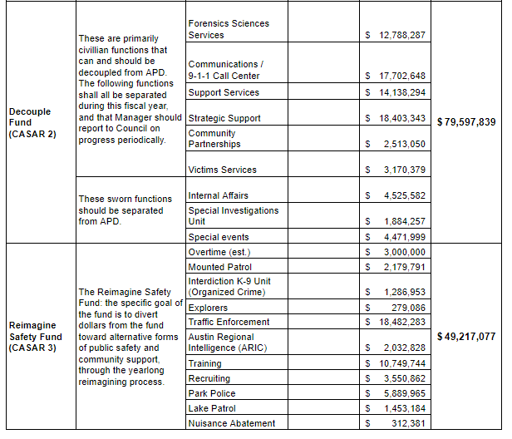
- Decouple Fund: Per the framework passed by Council in August, the following functions will be separated out from under APD if it is legally and structurally possible to streamline operations, reduce incidents of bias, and elevate the functions to higher levels in the City’s reporting structure. Again, it is important to note that changes to the functions in the Decouple Fund are being explored, and no changes have been finalized yet. Some of the functions may not be removed from APD if their removal changes their effectiveness or presents legal challenges.
  - These functions include civilian operations:
    - Forensic Sciences Services
    - Communications/9-1-1 Call Center
    - Support Services
    - Strategic Support
    - Community Partnerships
    - Victim Services
  - As well as sworn operations:
    - Internal Affairs
    - Special Investigations Unit
    - Special Events
Some examples of why these changes are needed:
  - There is long-standing evidence that DNA labs should be independent of police department to improve quality of investigation and reduce bias:
    - “Local officials, lawyers: To fix DNA lab’s woes, break away from police” – Statesman article from 2016
    - UT News Article on Same Issue
  - Internal Affairs is the unit that conducts investigations on officers accused of misconduct. There is a clear conflict of interest having members of the same police force investigate their colleagues. Investigations should be independent.
  - 9-1-1 Call Center/Communications: Separating the 9-1-1 call center increases the likelihood that other services (mental health or EMS) will be dispatched as appropriate, instead of defaulting to police for almost every call because there is a law enforcement bias or lack of comprehensive training in the dispatch center.
  - Victim Services will only be moved out if they can maintain co-location with APD units and can improve their access to resources and department files. Moving Victim Services out from under APD would also elevate the unit to a higher reporting status, with the VS Manager reporting directly to the Assistant City Manager over public safety instead of to the police chief.

- Reimagine Safety Fund: These functions have not been cut or yet changed in any way. Instead, these units have been identified for further review, exploring the potential separation or ending of operations under APD and diverting funds to alternative solutions. That review must be completed in order to address both whether and how such changes would be accomplished before action is taken. Learn more about the long-term Reimagine Safety Fund and how you can engage at http://austintexas.gov/publicsafety.
  - Officer Time Spent: Part of the issue that needs to be addressed is Officer Use of Time. An initial review of APD calls for service found that a plurality of calls for service were “responsive” calls – incidents that are not initiated by the officer. These may or may not be criminal in nature and include incidents like assisting other agencies, disturbances, and burglar alarms. The same analysis found that only 0.6% of calls were for violent crime, and 4.0% were for property crime.
  - See tables below for reference. You can watch AH Analytics’ presentation to Council here and you can access the full slide deck here.

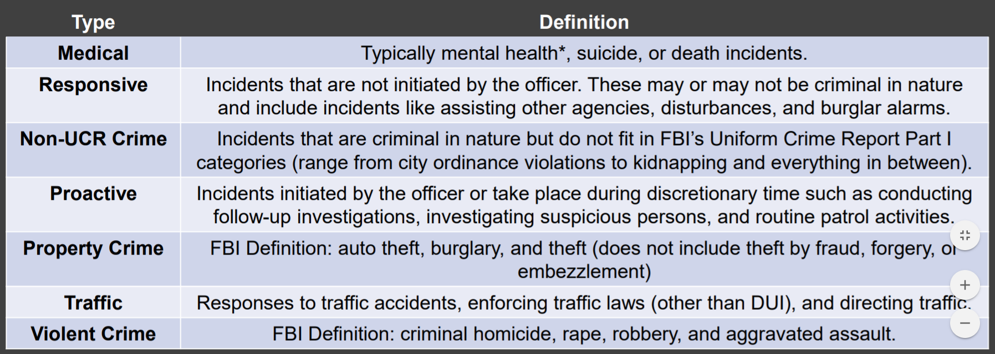
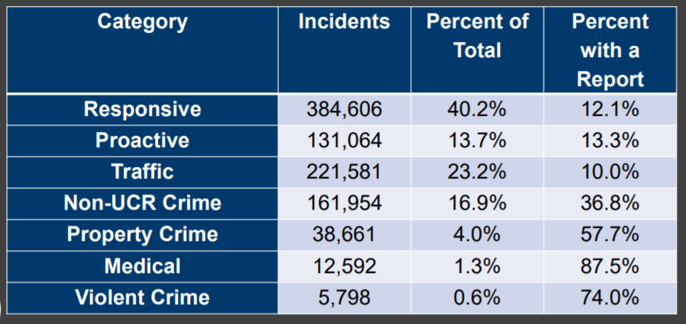

- A second, deeper analysis was done by the City’s Innovation Office. This analysis found that a plurality (45.8%) of APD calls for service were Priority 3, defined as “Incidents where life or property is not at risk and an immediate police response will not likely prevent further injury, loss of property or adversely affect an investigation. (E.g. DOC/City Ordinance Violation)”. The Innovation Office’s analysis also showed that the vast majority of burglar alarm calls for service are false, identifying an area for significant efficiencies and improvements to reduce the wasting of sworn officer time.
- See images below for reference. You can watch the Innovation Office’s full presentation to Council here, and you can access the full slide deck here. Several interactive data sets are available here for further analysis.
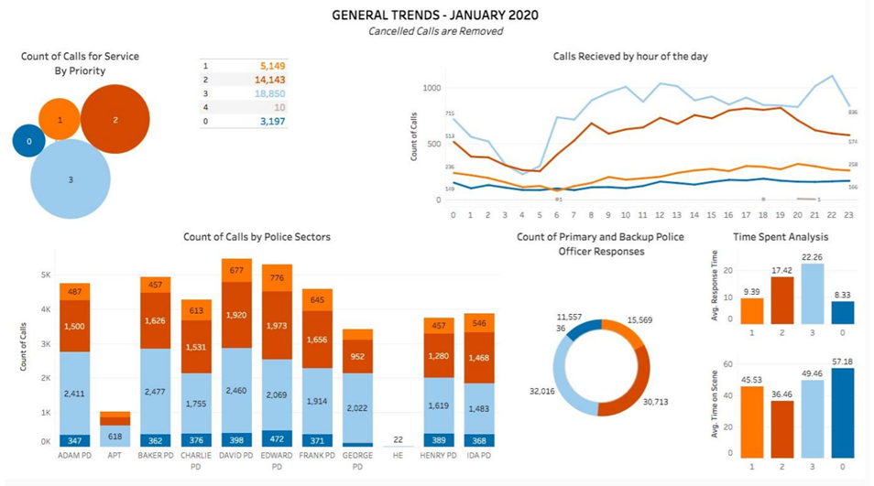
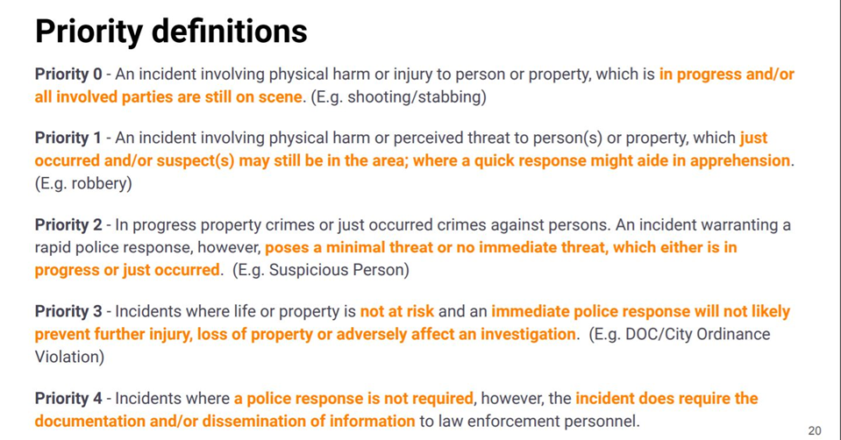

How many positions for police officers have been open throughout 2019 and 2020, and why have they not been filled?
- In the FY21 budget process, CM Alter submitted questions regarding vacancies and received the following answers. Note these numbers have changed over the last few months and vacancies grew.
  - As of June 30, 2020: 157 Total Sworn
  - Of the Total Vacancies above, the following have been unfilled for 6-12 months: 62 Sworn
  - Of the Total Vacancies above, the following have been unfilled for more than 12 months? 22 Sworn
    - These numbers are from the end of JUNE 2020. The City anticipates that the department will have 205 vacancies by Oct. 1, 2020 (the start of the fiscal year). These are “EMPTY CHAIRS”, meaning no officer is in that position, but the police department is receiving money for the position. On Oct. 1, 2020, the FY21 budget will go into effect, which cuts 150 vacancies (empty chairs). Also in October, the Feb. 2020 cadet class will graduate with an anticipated 47 cadets, bringing APD’s total vacancies down to 16. The average attrition rate is 7.5 positions/month, meaning APD vacancies will grow by 7.5 positions each month and the next cadet class will fill those vacancies.
- The department has struggled for years to retain talent. One year ago, the department still had 100 vacancies. Even with fully funded cadet academies, the department has been unable to catch up on filling those vacancies. It is important to note that the vacancies seen in June (which are projected to increase per standard attrition to about 180 vacancies by Oct. 2020) were not impacted by the decision to postpone all FY21 cadet classes. As noted previously, the Feb. 2020 class, which was the next scheduled class when the Dec. 2019 resolution was passed, continued as normal. The academy is eight (8) months long, meaning that the February class has yet to graduate. If the July class had continued as planned, those cadets would not have graduated until March 2021. There are many reasons for the high attrition rates and for difficulty filling vacancies, including issues with cadets leaving because of poor culture in the academy, and many officers retired early after the Austin Police Association voted to temporarily discontinue negotiations on the police contract even though they had the option to extend the contract while negotiations continued.

How much money has already been removed from the 2020-2021 budget that affects active policing and why?
- No existing officers have been fired or cut, and no pay was taken away from officers. All pay levels remain the same, and in fact, per the meet and confer contract, officers received a 2% pay raise this year. No funds for actively filled positions have been removed, and no units or functions have been eliminated by what council adopted.

How much more money is being contemplated to be removed from the 2020-2021 budget that affects active policing, and why?
- No discussions or proposals exist to cut or fire existing officers.

Can officers go on strike?
- No. Section 617.003 of the State Government Code states, “Public employees may not strike or engage in an organized work stoppage against the state or a political subdivision of the state.” This prohibition against strikes is also noted in the currently operative City of Austin APD meet and confer contract. The contract states the union “has pledged to support the service and mission of the Austin Police Department and to abide by the statutorily imposed no strike or work slowdown obligations placed upon it”.

