COYOTES AND FENCING -- Wildlife Committee

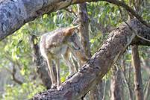
It’s a little known fact that coyotes can climb. Be aware of this fact when considering the safety of your pet that’s left outdoors for long periods of time, particularly from dusk until dawn.

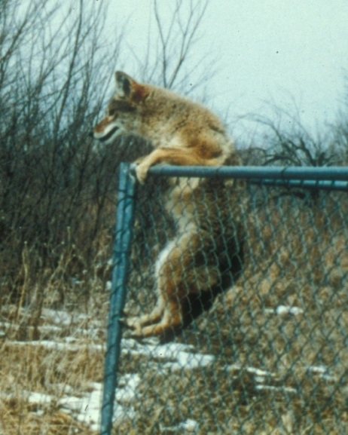
Coyotes are easily able to climb or jump over a chain-link fence. They are able to scale stone fences and wood fences that are built at a standard six feet. Any fencing that they are not able to climb, such as iron fencing, they can dig underneath in pursuit of food or prey.

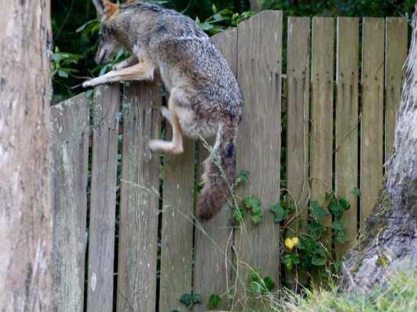
Owners of pets are advised to walk along your fencing from time to time to observe if there is any evidence of digging. If there has been any reported coyote activity near you, this is particularly important. Coyote scat is typical of dog poop, except it will also contain fur, bits of bone and cartilage, berries etc.

NWACA residents are advised that the intentional and unintentional feeding of wildlife contributes to the dangerous habituation of coyotes. A coyote that associates humans with food will become increasingly aggressive in pursuit of that available food or source of prey.

