Was that a Coyote or a Fox?
Wildlife Committee, July 2015
Coyotes and foxes are both opportunistic and they can thrive in urban and suburban areas by feasting on a variety of natural and human-supplied foods. They are both successful urban mammals, so it is no surprise that we are seeing them both in our neighborhoods and even our own backyards.

Keep foxes and coyote at bay by securing your garbage, feed pets indoors, do not feed other wildlife (such as deer, bunnies, squirrels), and if you are comfortable doing so, use hazing to help re-instill fear of humans.

The chart shows ways to tell a coyote from a red fox.

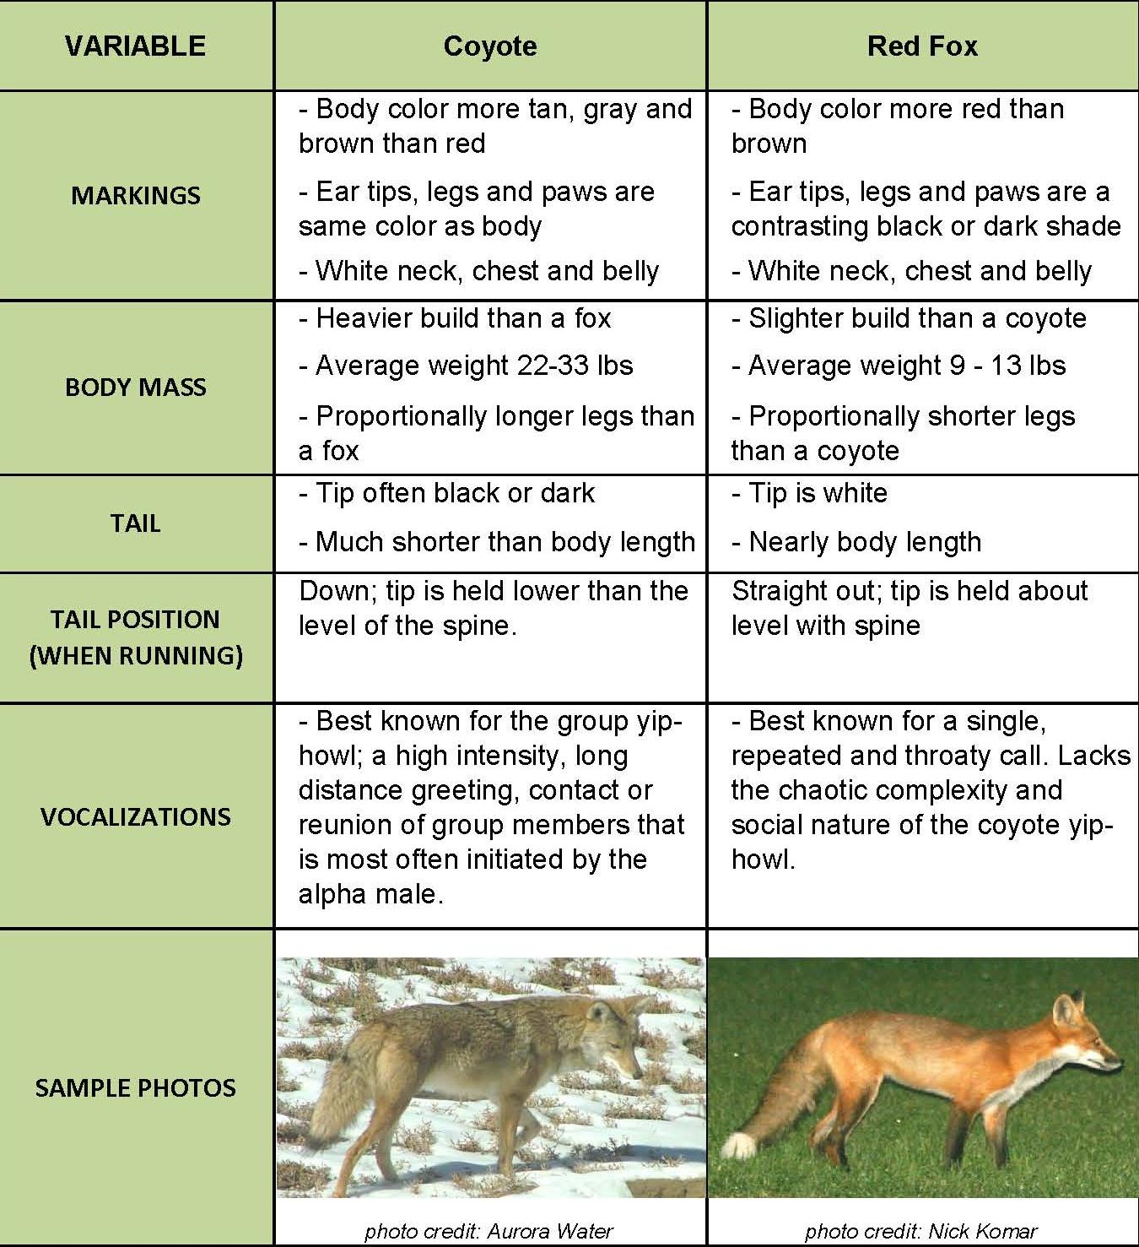

Source: https://www.auroragov.org/cs/groups/public/documents/document/012561.pdf

