Coyote Pup Rearing Season Awareness
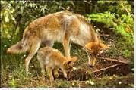
Carolyn Abernathy, April, 2015

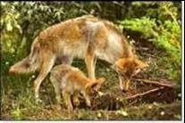
Now is the time to be aware of coyote pup rearing season. Here are some valuable facts:
- Coyotes breed in February and March; pups are born about 60 days later.
- During this time, territorial male coyotes do not tolerate other canines in their territory; many conflicts between coyotes and domestic dogs result from this territorial behavior.
- An average coyote litter contains 4 or 5 pups, born in dens. In urban environments, dens can be in storm drains, under storage drains, in holes dug in vacant lots, parks, golf courses or any other dark, dry place.
- Coyote pups are cared for, fed, and protected by both parents. The pups mature quickly and can eat meat and move about well by the time they are a month old.
- Food requirements of the nursing females and the growing young remain high until late summer. As people and their pets spend more time outdoors during this time, the possibility of a coyote encounter increases.
- It is not unusual to observe a family of coyotes traveling through urbanized areas.
- If food is deliberately or inadvertently provided by people, the pups quickly learn not to fear humans and develop a dependency on easy food sources.
As a reminder, evaluate what food attractants you may be inadvertently providing. Pick ripe fruit from trees and off the ground, secure garbage and compost bins, don’t feed pets outdoors, don’t throw food scraps for wildlife, keep bird feeders from overflowing, eliminate artificial water sources. Additionally, close off crawl spaces under porches, decks, and sheds!
Thank you for sharing this information with your neighbors!
Sources: Wildlife Services, Factsheet, December 2011, “Coyotes in Towns and Suburbs.” Colorado Parks & Wildlife, “Your Guide to Avoiding Human-Coyote Conflicts.”

